**Model Card: Lyrics Generation**

**Model Name:**

Fine-tuned GPT-2[7](Custom Variant)

Fine-tuned Parameters: Output Hidden States (True), Use Cache (False), Layer Norm Epsilon (1e-5), Dropout (0.1)

**Intended Use:**

The objective of this model is to generate song lyrics given a prompt. This model is intended to be used for generating song lyrics for creative and entertainment purposes. It can be utilized by songwriters, musicians, or anyone interested in generating text in the style of song lyrics.

**Limitations and Ethical Considerations:**

*1. Language Bias:* The model's outputs may reflect biases present in the training data, including cultural, gender, or racial biases.

*2. Originality:*The generated lyrics may resemble existing songs or lyrics due to the nature of the training data and the model's ability to learn patterns.

**Evaluation Metrics:**

The model's performance can be evaluated based on the following metrics:

*Perplexity:* A measure of the model's uncertainty in predicting the next token in a sequence. Lower perplexity indicates better performance.

*Human Evaluation:* Subjective assessment by human evaluators to judge the coherence, relevance, and creativity of the generated lyrics.

**Training and Evaluation Data:**

*Training Data:* The model was fine-tuned on a custom dataset comprising song lyrics collected from various sources. The dataset includes lyrics from diverse genres and artists to ensure a broad representation of language styles and themes. The training set consists of 80% of the total data, randomly selected.

*Validation Data:* A randomly chosen 20% subset of the training data was used for model evaluation and validation. This subset ensures that the model's performance is assessed on unseen data, helping to gauge its generalization ability.

**Caveats and Recommendations:**

The generated lyrics from this model should be interpreted with caution due to potential contextual limitations, biases inherited from the training data, and vocabulary constraints. Users are advised to provide clear and relevant prompts.

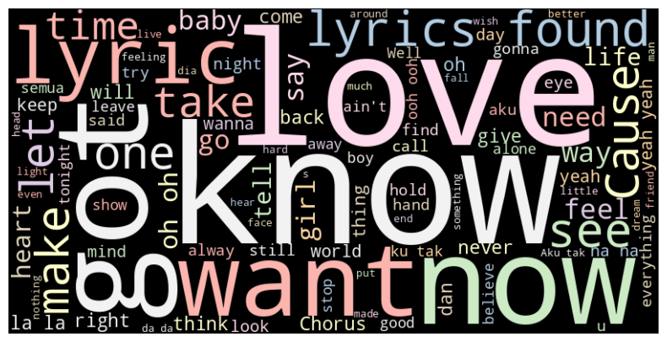

*Fig: Word Cloud for lyrics*

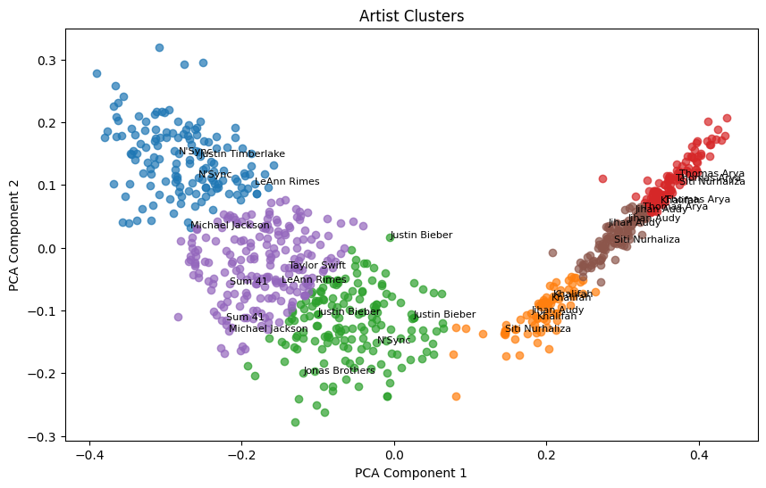

*Fig: PCA based biplot for Artists*